**IR Sensor Working and Applications**

Now a days, an Infrared technology has a wide variety of wireless applications mostly in object sensing and remote controls.

In the [**electromagnetic spectrum**](https://en.wikipedia.org/wiki/Electromagnetic_spectrum), the infrared portion divided into three regions: near infrared region, mid infrared region and far infrared region.

In this blog we are talking about the IR sensor working principle and its applications.

## **What is an IR Sensor?**

IR sensor is an electronic device, that emits the light in order to sense some object of the surroundings. An [**IR sensor**](https://robu.in/product-category/sensor/ir-and-pir-sensor/) can measure the heat of an object as well as detects the motion. Usually, in the [**infrared spectrum**](https://en.wikipedia.org/wiki/Infrared_spectroscopy), all the objects radiate some form of thermal radiation. These types of radiations are invisible to our eyes, but infrared sensor can detect these radiations.

[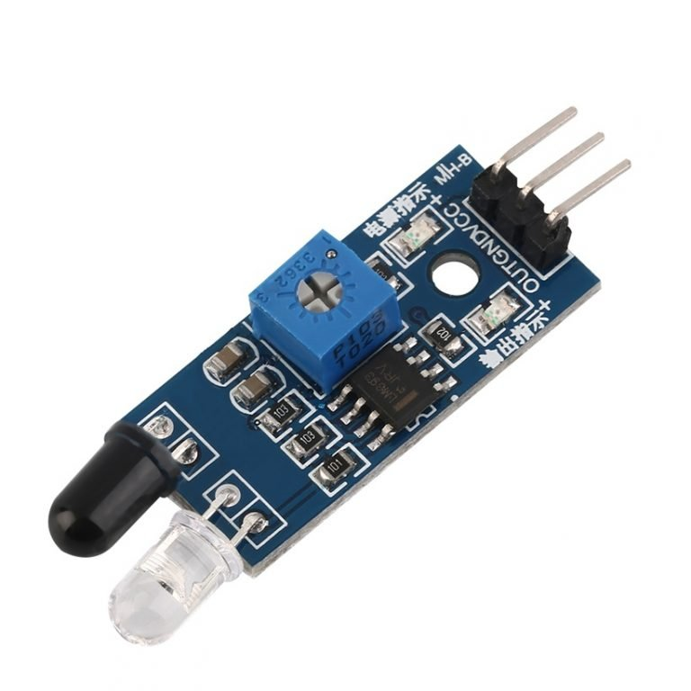](https://robu.in/wp-content/uploads/2020/05/robu-3-768x768-1.jpg)

The emitter is simply an IR LED [**(Light Emitting Diode**](https://robu.in/product-category/display-boards/led/)) and the detector is simply an IR photodiode . Photodiode is sensitive to IR light of the same wavelength which is emitted by the IR LED. When IR light falls on the photodiode, the resistances and the output voltages will change in proportion to the magnitude of the IR light received.

There are five basic elements used in a typical infrared detection system: an infrared source, a transmission medium, optical component, infrared detectors or receivers and signal processing. Infrared lasers and Infrared LED’s of specific wavelength used as infrared sources.

The three main types of media used for infrared transmission are vacuum, atmosphere and optical fibers. Optical components are used to focus the infrared radiation or to limit the spectral response.

## **Types of IR Sensor**

There are two types of IR sensors are available and they are,

* Active Infrared Sensor
* Passive Infrared Sensor

### **Active Infrared Sensor**

Active infrared sensors consist of two elements: infrared source and infrared detector. Infrared sources include the LED or infrared [**laser diode**](https://robu.in/product-category/electronic-module/laser-module/). Infrared detectors include photodiodes or phototransistors. The energy emitted by the infrared source is reflected by an object and falls on the infrared detector.

### **Passive Infrared Sensor**

Passive infrared [**sensors**](https://robu.in/product-category/sensor/) are basically Infrared detectors. Passive infrared sensors do not use any infrared source and detector. They are of two types: quantum and thermal. Thermal infrared sensors use infrared energy as the source of heat. [**Thermocouples**](https://robu.in/product/max6675-thermocouple-sensor-module/), pyroelectric detectors and bolometers are the common types of thermal infrared detectors. Quantum type infrared sensors offer higher detection performance. It is faster than thermal type infrared detectors. The photo sensitivity of quantum type detectors is wavelength dependent.

## **IR Sensor Working Principle**

There are different types of infrared transmitters depending on their wavelengths, output power and response time. An IR sensor consists of an IR LED and an IR Photodiode, together they are called as PhotoCoupler or OptoCoupler.

**IR Transmitter or IR LED**

Infrared Transmitter is a light emitting diode (LED) which emits infrared radiations called as IR LED’s. Even though an IR LED looks like a normal LED, the radiation emitted by it is invisible to the human eye.

The picture of an Infrared LED is shown below.

[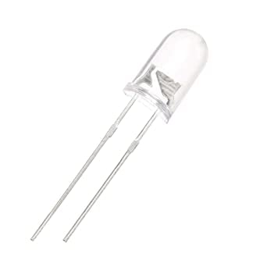](https://robu.in/wp-content/uploads/2020/05/51fibl-5xL._SX342_.jpg)

**IR Receiver or Photodiode**

Infrared receivers or infrared sensors detect the radiation from an IR transmitter. IR receivers come in the form of photodiodes and phototransistors. Infrared Photodiodes are different from normal photo diodes as they detect only infrared radiation. Below image shows the picture of an IR receiver or a photodiode,

[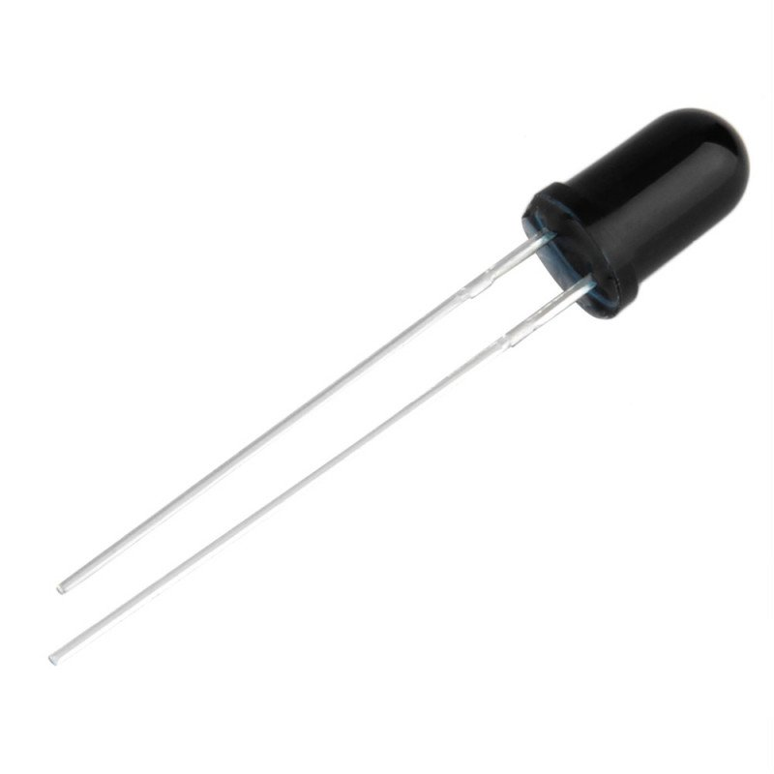](https://robu.in/wp-content/uploads/2020/05/SN-IR-R-0-1-1-800x800-1.jpg)

Different types of IR receivers exist based on the wavelength, voltage, package, etc. When used in an infrared transmitter – receiver combination, the wavelength of the receiver should match with that of the transmitter.

The emitter is an IR LED and the detector is an IR photodiode. The IR photodiode is sensitive to the IR light emitted by an IR LED. The photo-diode’s resistance and output voltage change in proportion to the IR light received. This is the underlying working principle of the IR sensor.

[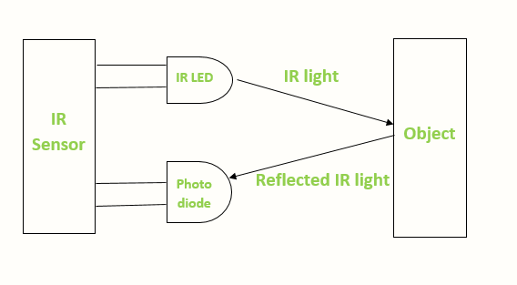](https://robu.in/wp-content/uploads/2020/05/IR-sensor-Working.png)

When the IR transmitter emits radiation, it reaches the object and some of the radiation reflects back to the IR receiver. Based on the intensity of the reception by the IR receiver, the output of the [**sensor**](https://robu.in/product-category/sensor/) defines.

## **Applications of IR Sensor**

IR sensors use in various projects and also in various electronic devices. They all are as follow,

### **IR Sensor Circuit Diagram**

An infrared sensor circuit is one of the basic and popular sensor modules in an [electronic device](https://www.elprocus.com/basic-components-used-electronics-electrical/). This sensor is analogous to human’s visionary senses, which can be used to detect obstacles and it is one of the common applications in real-time. This circuit comprises the following components

* [LM358 IC](https://www.elprocus.com/op-amp-ics-pin-configuration-features-working/) 2 IR transmitter and receiver pair
* Resistors of the range of kilo-ohms.
* Variable resistors.
* LED (Light Emitting Diode).

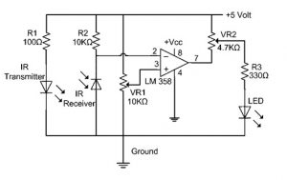

***Infrared Sensor Circuit Diagram***

In this project, the transmitter section includes an IR sensor, which transmits continuous IR rays to be received by an IR receiver module. An IR output terminal of the receiver varies depending upon its receiving of IR rays. Since this variation cannot be analyzed as such, therefore this output can be fed to a comparator circuit. Here an [operational amplifier](https://www.elprocus.com/op-amp-ics-pin-configuration-features-working/) (op-amp) of LM 339 is used as a comparator circuit.

When the IR receiver does not receive a signal, the potential at the inverting input goes higher than that non-inverting input of the comparator IC (LM339). Thus the output of the comparator goes low, but the LED does not glow. When the IR receiver module receives a signal to the potential at the inverting input goes low. Thus the output of the comparator (LM 339) goes high and the LED starts glowing.

Resistor R1 (100 ), R2 (10k ), and R3 (330) are used to ensure that a minimum of 10 mA current passes through the IR LED Devices like Photodiode and normal LEDs respectively. Resistor VR2 (preset=5k ) is used to adjust the output terminals. Resistor VR1 (preset=10k ) is used to set the sensitivity of the circuit Diagram. Read more about IR sensors.

S